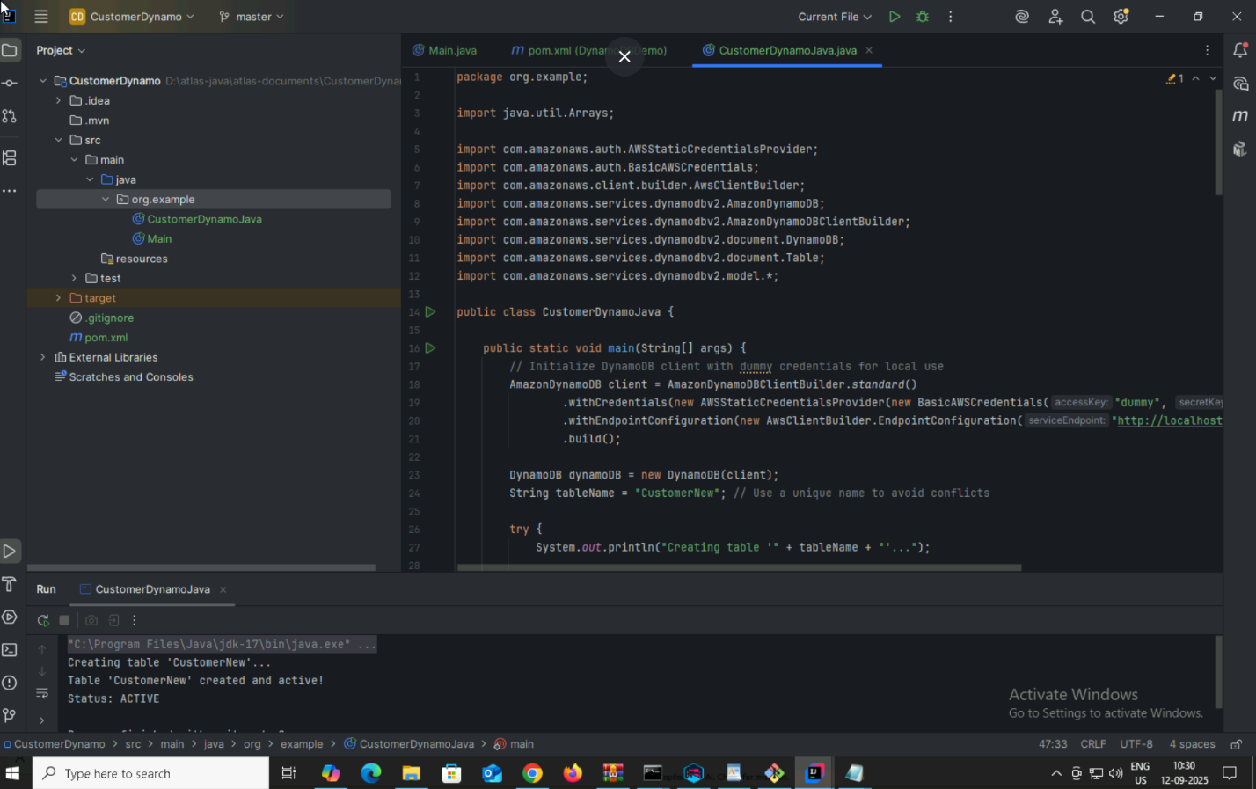

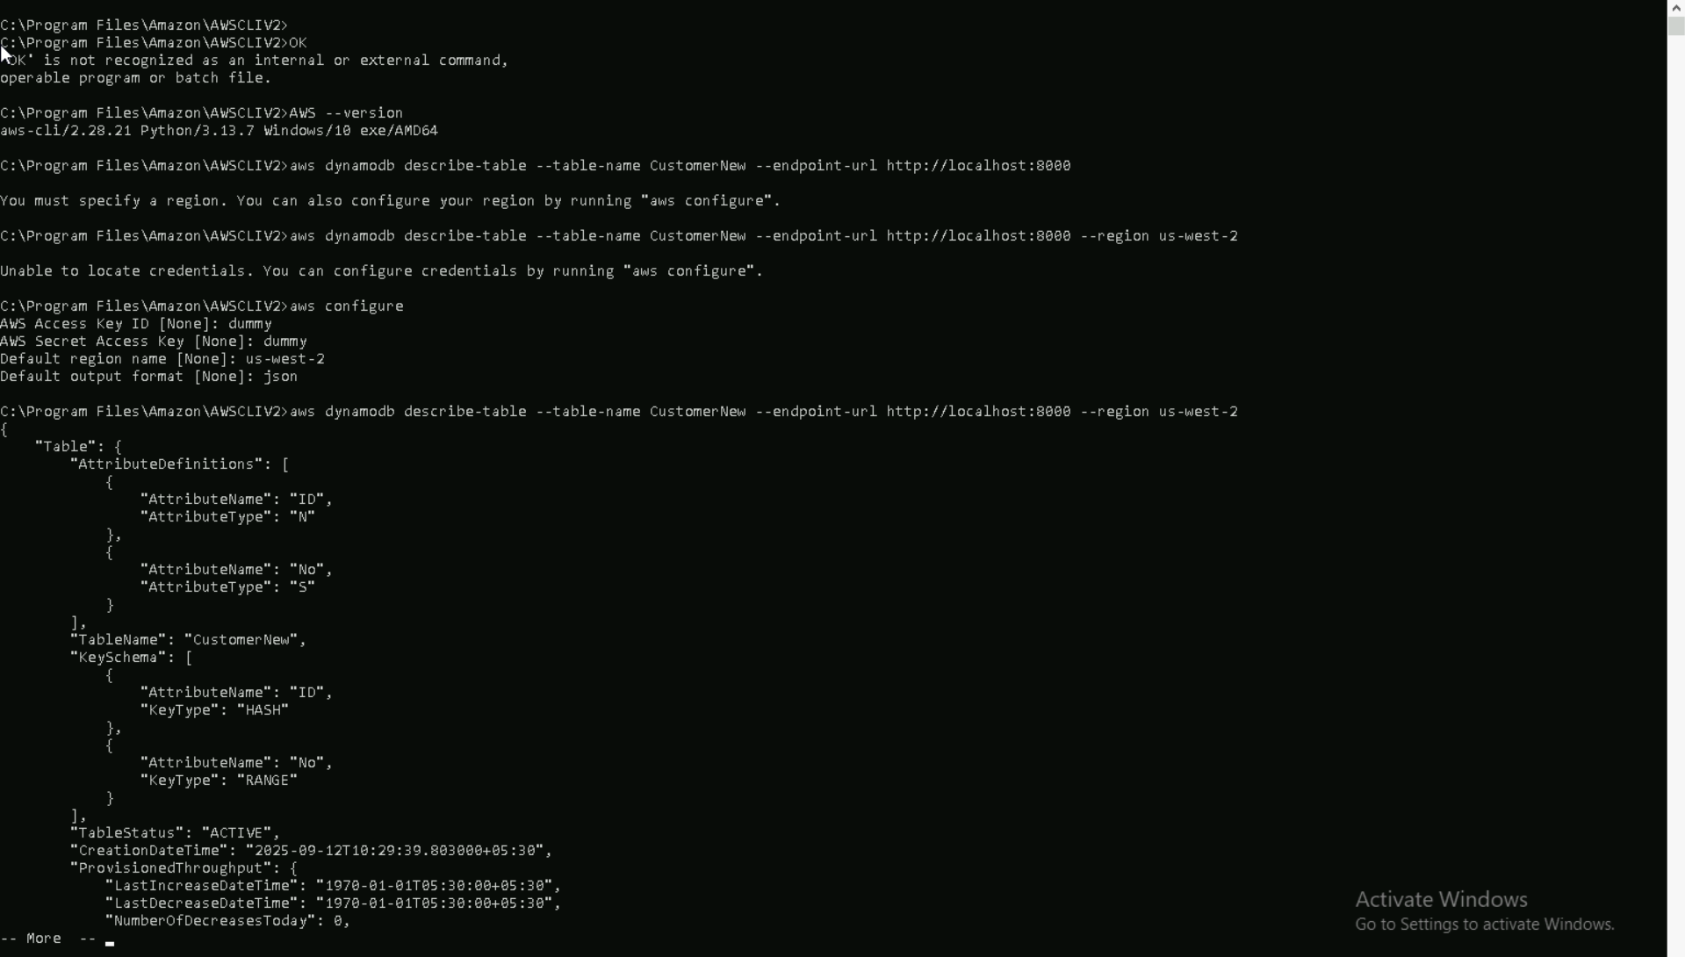

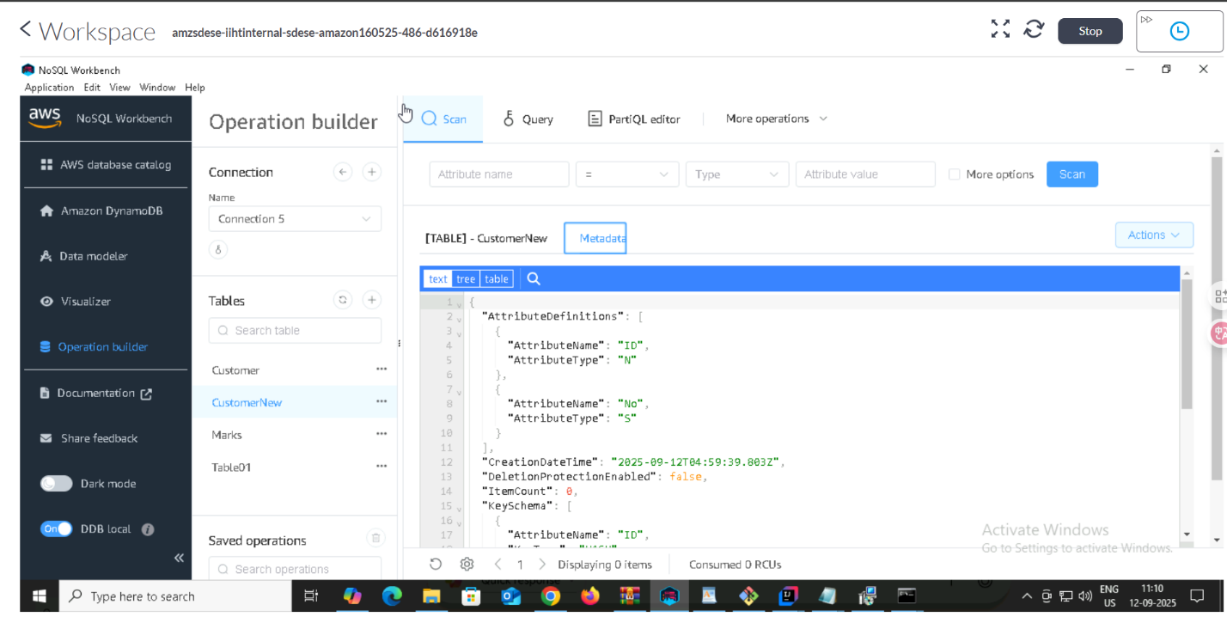

TASK: Inserting Data.

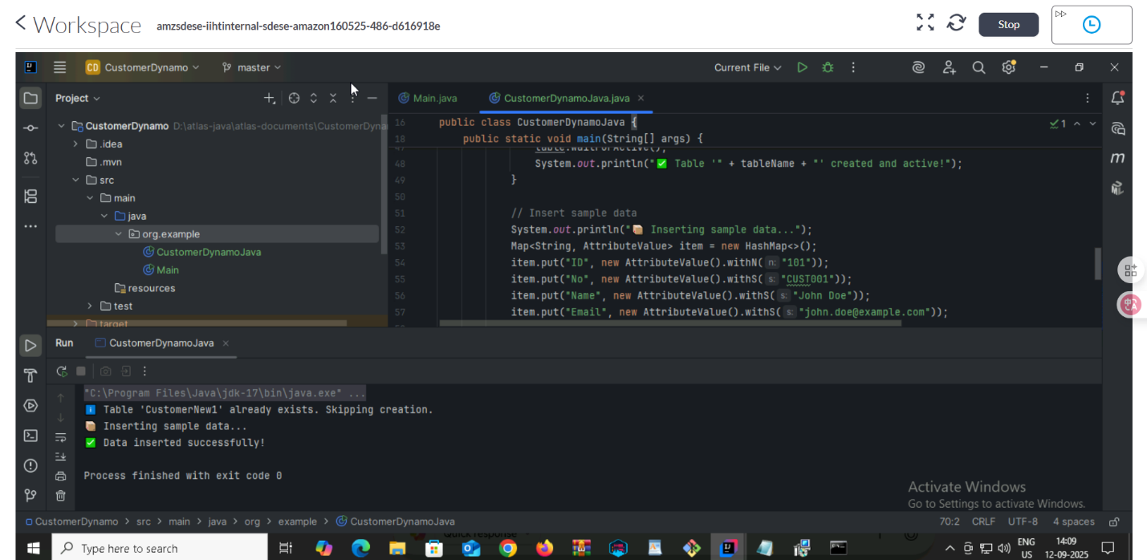

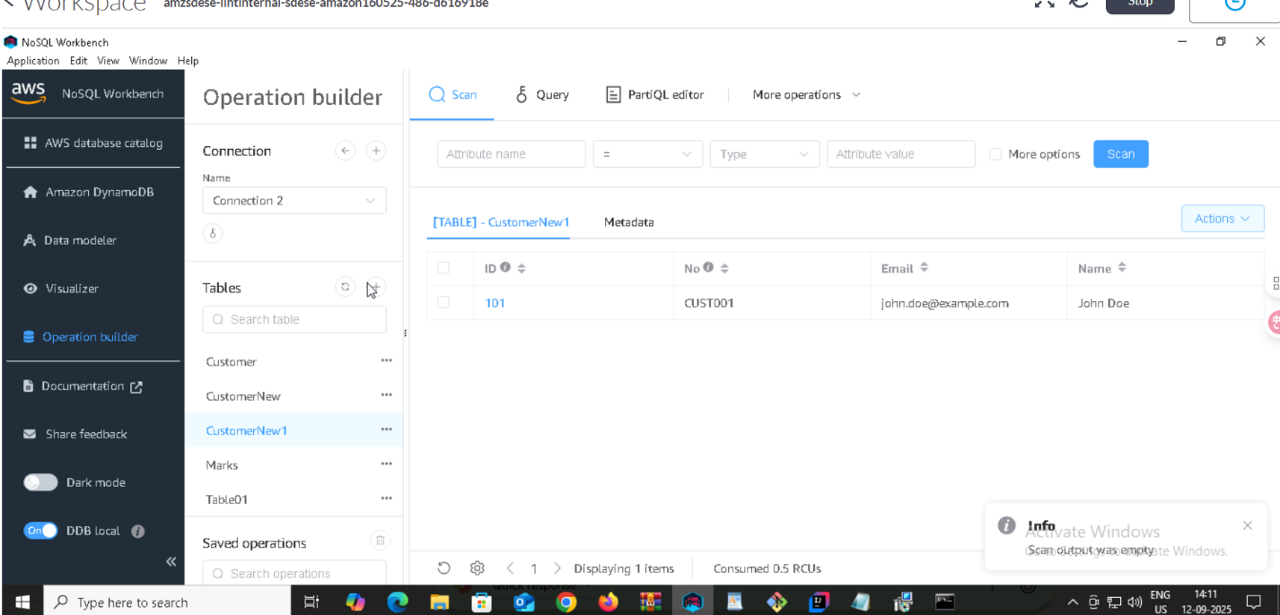

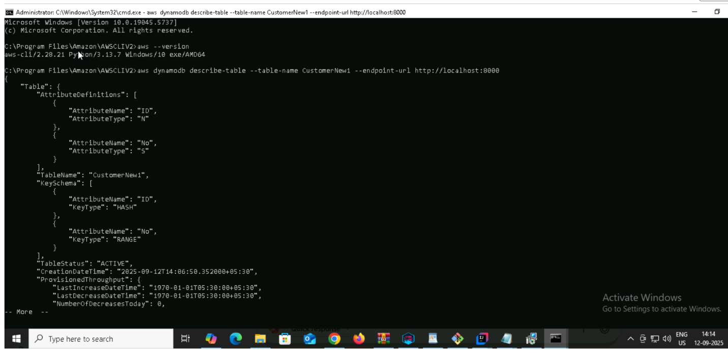

Scanning:

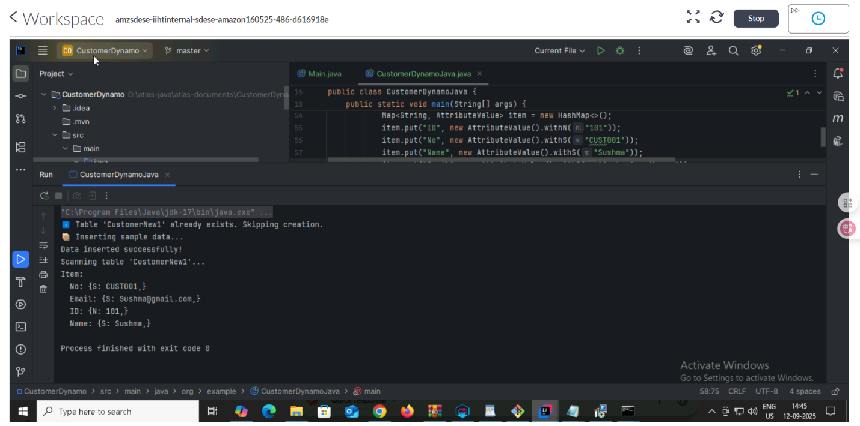

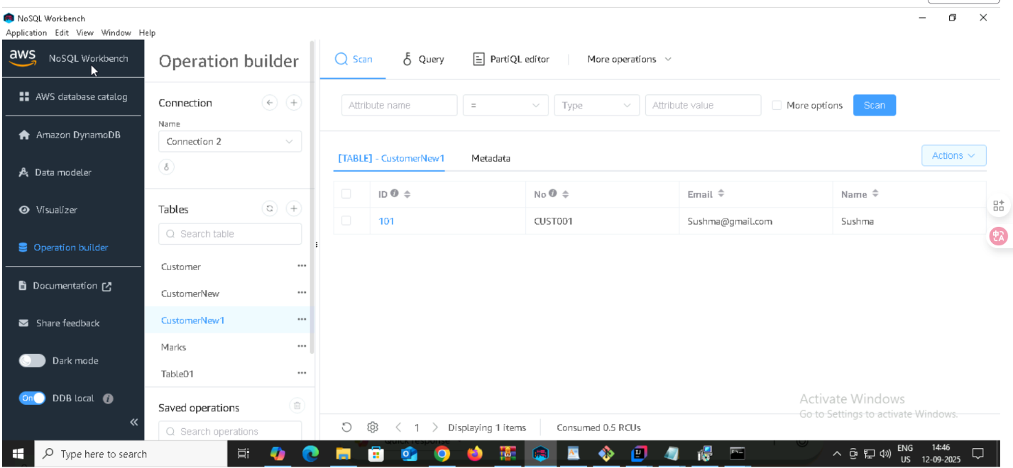

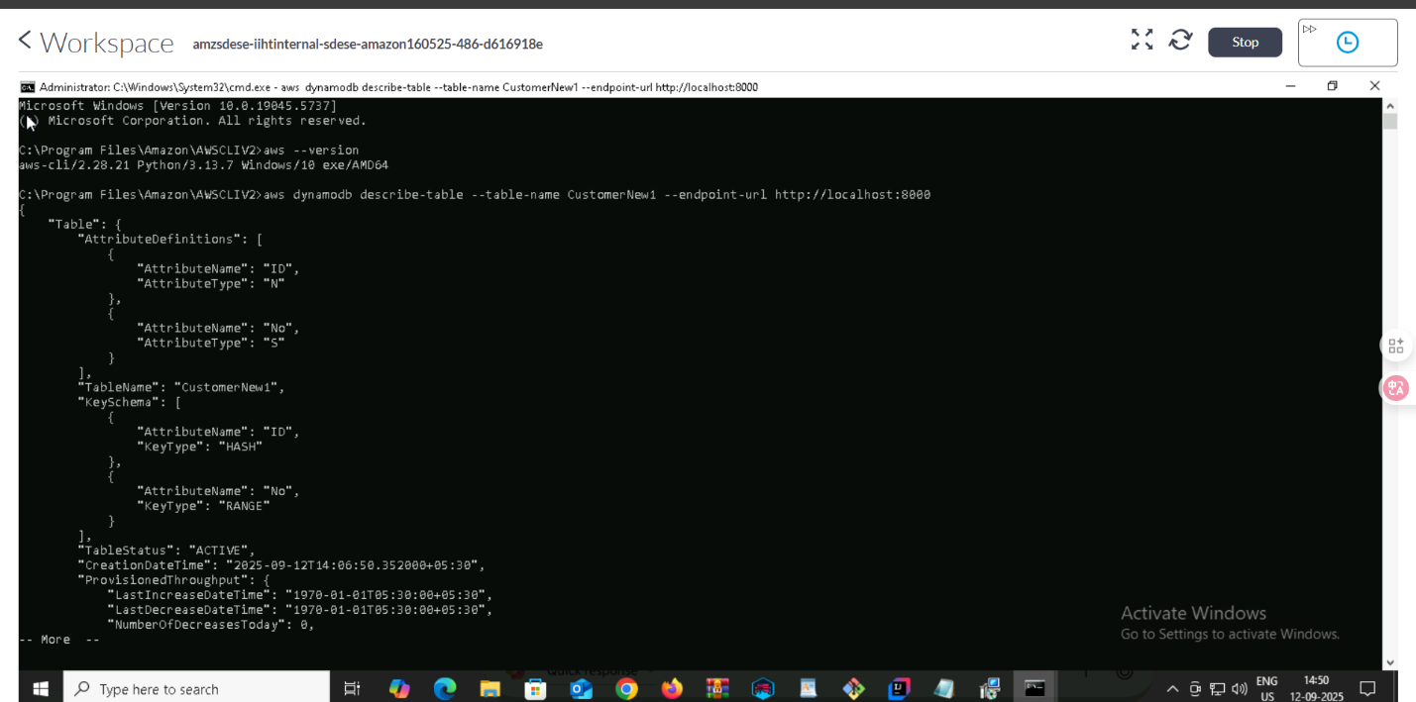

Added manually in SQL workbench and then executed the existed code to check whether its reflecting or not

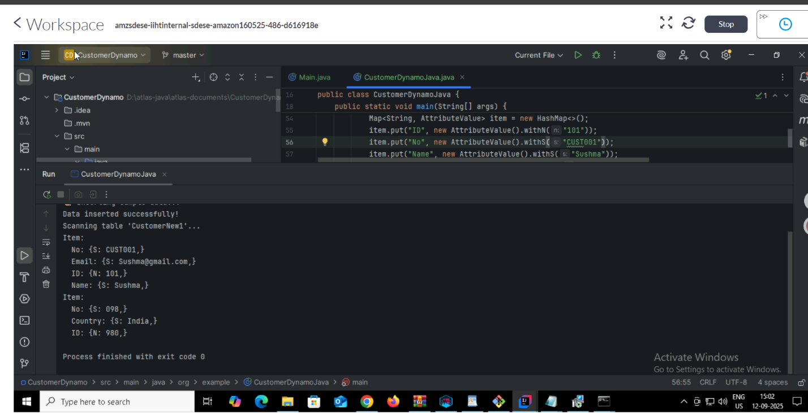

Task 07:

How do you lower the cost of DynomaDB..explain ways to do so…

1. Optimize Table Design like Avoid using large items, as DynamoDB charges based on item size.

2. by using capacity mode

3. Use Reserved Capacity for fixed period which can provide significant cost savings compared to on-demand pricing.

4. Monitor your table's capacity usage and adjust your provisioned capacity accordingly.

- Use CloudWatch metrics to track your table's usage and adjust your capacity to match your workload.

5. Use DynamoDB Accelerator (DAX)

6. Use Efficient Data Retrieval

7. Avoid Overwriting Items Unnecessarily

8. Use Batch Operations

9. Use TTL (Time-To-Live)

Task 08:

Update item details using java code.. And check if it reflects in the server..

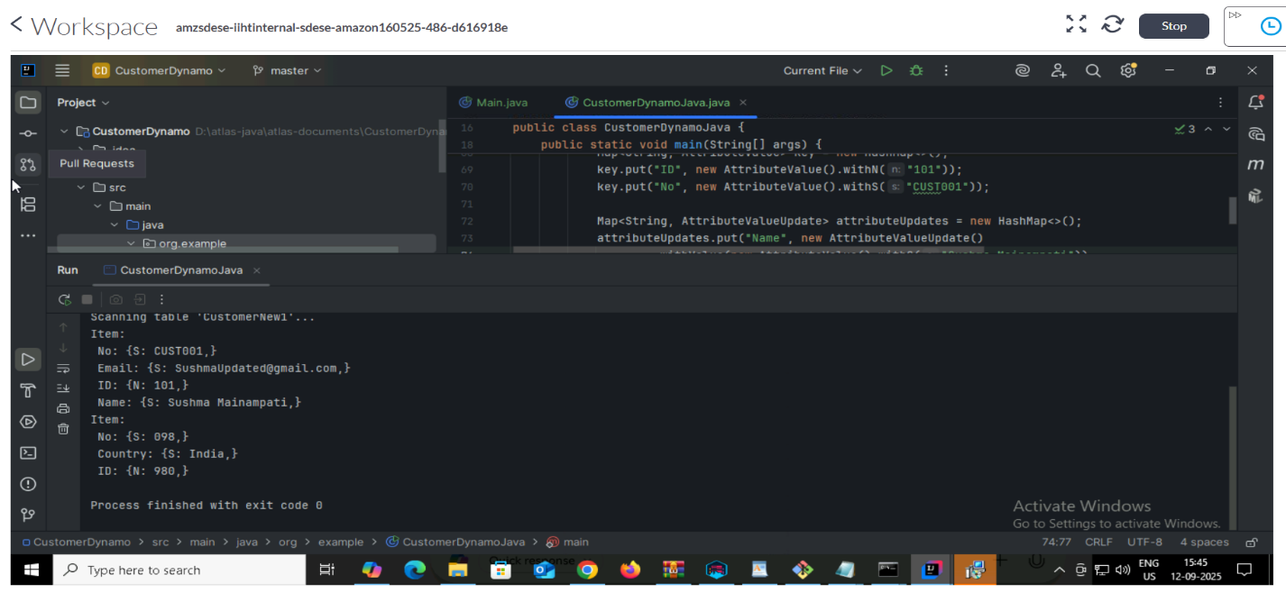

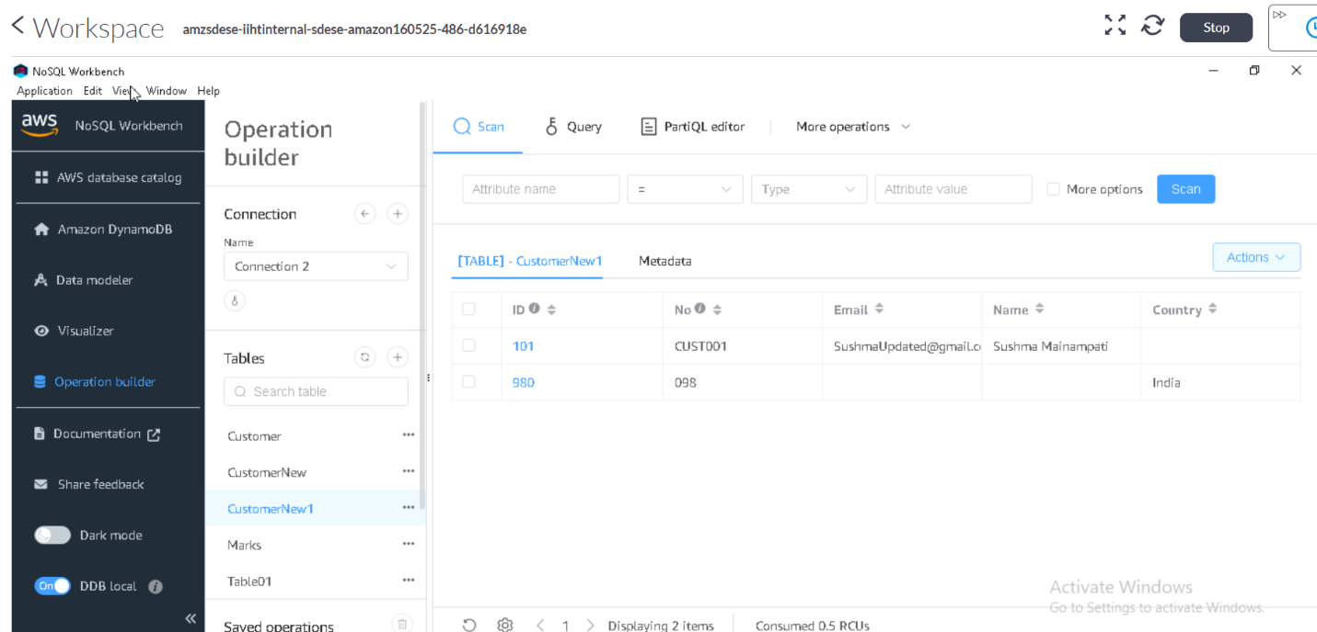

Deleting Item:

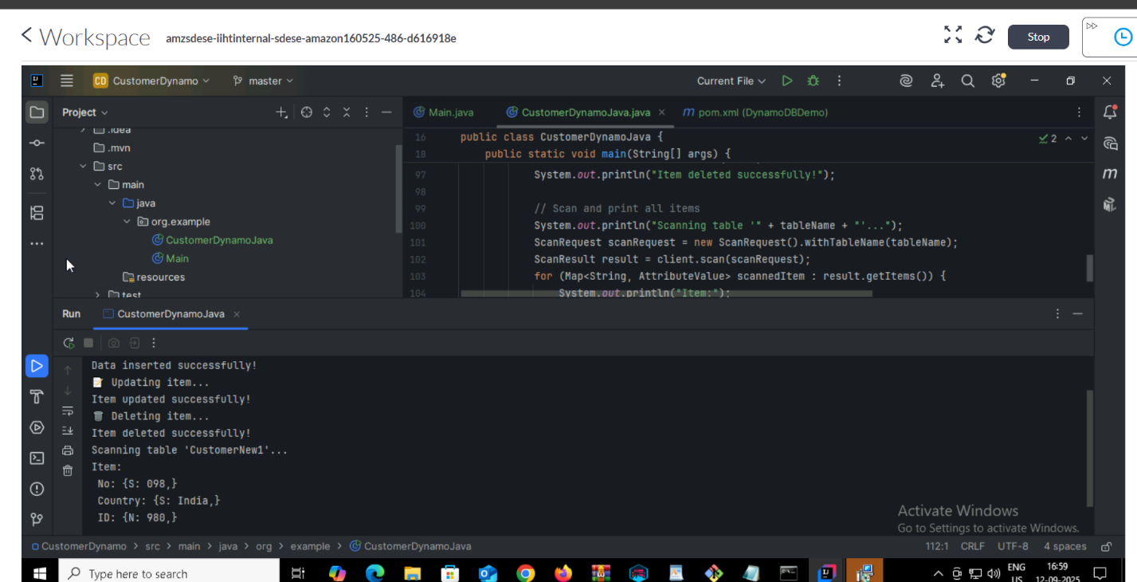

Home Task:

1.What are the features of DynamoDB?

1. High Performance

2. Scalability

Supports key-value and document data models.

No need to define a schema before adding data.

4. Security

5. Integration

6. Cost-Effective

7.TTL (Time-To-Live)Supports TTL for automatic item expiration.

2. Disadvantages of DynamoDB?

1. It has limited query capabilities compared to traditional relational databases.

2. not support complex transactions.

3. it has limitations on data retrieval, including limits on the amount of data

4. Throughput Limitations

Task: 3:Where do we use dynamoDB(the uses cases of DynamoDb)

Real-time Analytics,Gaming,E-Commerce,User Data storage,serverless applications etc

What is DynamoDBMapper?

It’s a access layer developers to work with Java objects instead of directly interacting with the DynamoDB API.

What are projections in DynamoDB?

Keys only, include,all

How can you say DynamoDB prevents Dataloss?

DynamoDB automatically replicates data across multiple AZs, providing high availability and durability, Point-in-Time Recovery,Backup and Restore.